Tree HW #1 Name__________________

A) Given the tree to the right, find:  - the root:  - list each leaf:  - draw a picture of the right subtree  - list the descendants of the node K:  - list the ancestors of the node W:  - draw the subtree with root Y  - find the depth (height) of the tree:  - find the depth of node L:  - find the depth of node T:  - write the Inorder traversal:  - write the Preorder traversal:  - write the Postorder traversal:  - how many nodes would you have to add to make it a Complete tree:  - how many nodes would you have to add to make it a Full tree:  B) draw the Binary Search Tree whose elements are inserted in the following order:  50, 72, 96, 94, 107, 26, 12, 11, 9, 2, 10, 25, 51, 16, 17  - write the Preorder traversal:  - write the Postorder traversal:  C) given a 12 node tree, find:  - the maximum depth (height):  - the minimum depth:  - the maximum depth for an n-Node tree:  - the minimum depth for an N-node tree:  D) given a tree of depth 3, find:  - the maximum number of nodes:  - the minimum number of nodes:  - the maximum number of nodes for a tree of height n:  - the minimum number of nodes for a tree of height n: | 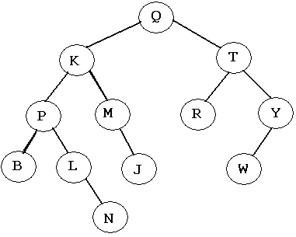

Tree HW #2 Name__________________
1. Write the Inorder traversal of this tree:  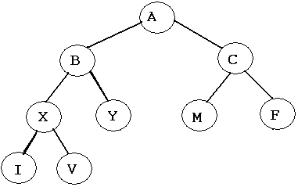  3. Write the Preorder traversal of this tree:  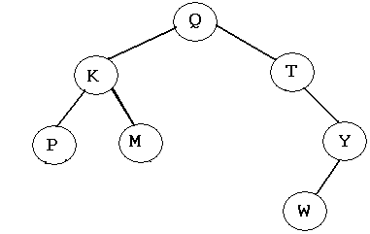  5. Write the Inorder traversal of this tree:  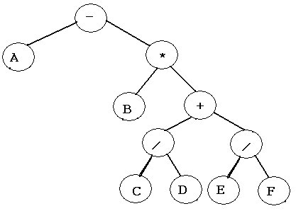 | 2. Write the Postorder traversal of this tree:  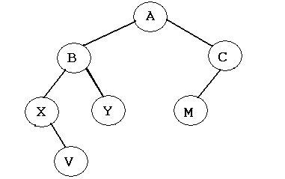  4. Write the Postfix expression and evaluate:  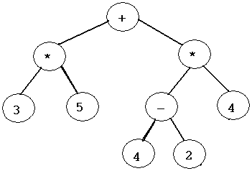  6. Draw a tree for which the Inorder output is: X A Y B Z C D Q E

7. What is the maximum number of leaves in a binary tree of:
A) height 3?

B) height 10?

C) height n?

8. When removing a node from a Binary Search Tree, there are three cases that must be considered:
1) If the node to be deleted is a leaf, set its parent pointer to null.

2) If the node to be deleted has one child, set its parent pointer to its child.

3) If the node has two children, replace that node’s data with the maximum node in its left subtree (which we will call node x), then delete node x. The tree will maintain its order.

Redraw each binary search tree with the node containing 5 deleted:

1)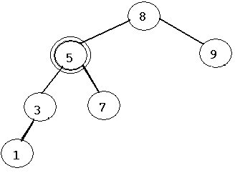  3)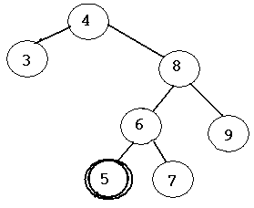  5)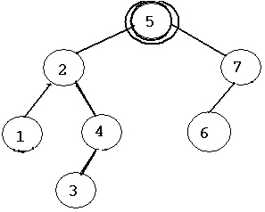 | 2)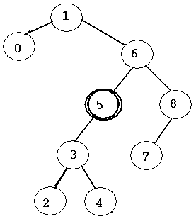  4)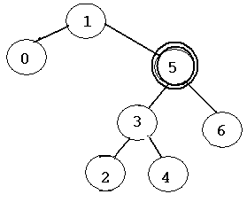  6)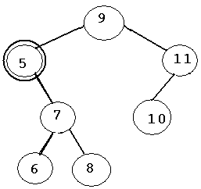
Tree HW #3 Name__________________
AP Test Question 1996 #3, modified for Java
In a binary tree, a leaf x is said to be to the left of a leaf y if there exists a node n such that x is in the left subtree of n and y is in the right subtree of n.  Using the binary TreeNode declaration to the right, write a method that will assign a number to the value fields of the leaves. You may assume that any and all nodes of the tree have been properly initialized. | public class TreeNode  {  private Object value; private TreeNode left;  private TreeNode right;  public TreeNode(Object initValue)  { value = initValue; left = null; right = null; }  public TreeNode(Object initValue, TreeNode initLeft,  TreeNode initRight)  { value = initValue; left = initLeft; right = initRight; }  public Object getValue()  { return value; }  public TreeNode getLeft()  { return left; }  public TreeNode getRight()  { return right; }  public void setValue(Object theNewValue)  { value = theNewValue; }  public void setLeft(TreeNode theNewLeft)  { left = theNewLeft; }  public void setRight(TreeNode theNewRight)  { right = theNewRight; }  }
For example, to call numberLeaves(root, new Integer(3)) will set the following trees values to:
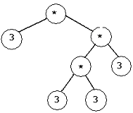
The nodes containing * are unaffected by the method.

//pre: root initially points to the first node in a binary tree
//post: leaves values are assigned to nextNum
public void numberLeaves (TreeNode root, int nextNum)
{

}
Tree HW #4 Name__________________
AP Test Question 1997 #3, modified for Java
a. Write a method countNum, whose header is given below. countNum returns the number of nodes in a tree T that contains the value key.  For example, if T is a tree that contains the data 0,4,1,1,0,1, countNum(T, 0) will return 2, countNum(T, 1) returns 3 and countNum(T,2) returns 0. | public class TreeNode  {  private Object value; private TreeNode left;  private TreeNode right;  public TreeNode(Object initValue)  { value = initValue; left = null; right = null; }  public TreeNode(Object initValue, TreeNode initLeft,  TreeNode initRight)  { value = initValue; left = initLeft; right = initRight; }  public Object getValue()  { return value; }  public TreeNode getLeft()  { return left; }  public TreeNode getRight()  { return right; }  public void setValue(Object theNewValue)  { value = theNewValue; }  public void setLeft(TreeNode theNewLeft)  { left = theNewLeft; }  public void setRight(TreeNode theNewRight)  { right = theNewRight; }  }
//post: returns the number of nodes in a tree T with the value key.
// returns 0 if no nodes contains this value or if the tree is empty.
public int countNum (TreeNode T, int key)
{

}
b. Write method insert, whose header is given below. Insert creates a new node containing the value key and inserts this new node between the node pointed to by P and either its right child (if direction is ‘R’) or its left child (if direction is ‘L’). If direction is ‘R’, the right child of P becomes the right child of a new node and the new node becomes the right child of P. If direction is ‘L’, the left child of P becomes the left child of the new node and the new node becomes the left child of P.
For example: Before insert(P, 3, ‘R’) After the call insert(P, 3, ‘R’)
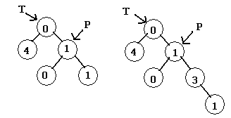
c. Write the method separate, whose header is given below. Separate modifies tree T in the following way: for each occurance of a parent and child that contain the same value n, a new node is inserted between them containing the value n-1.
For example: Before separate(T) After the call separate(T)
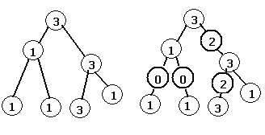
In writing separate, you may call the method insert of part (b). Assume that insert works as specified, regardless of what you wrote in part (b).

Complete the method separate below the following header:

public void separate(TreeNode T)
{

AP Question 1995 #4 Name___________________
Write method changeTree, whose header is given below. changeTree removes from tree T all nodes that have exactly one child, replacing the removed node with the child.
For example: after the call changeTree(T)
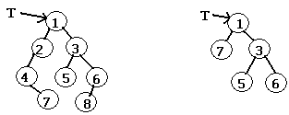

In writing method changeTree, you may call method hasOneChild, defined below:
public boolean hasOneChild(TreeNode T)
{
boolean state = false;
if (T != null)
state = ((T.getLeft()!=null && T.getRight()==null) ||
(T.getLeft()==null && T.getRight()!=null));
return state;
}
Complete method changeTree below the method header.
public void changeTree(TreeNode T)
{

}

